Hi Team SELAC,

Club Champs is over and back to normal Saturday competition this week. Remarkable efforts over the last couple of weeks.

PB’s
Last week 297 new PB’s
This week 354 new PB’s – That is just Crazy!! .

Special mention goes to these athletes you achieved the highest amount of PB’s – Leila Lesa (7), Bille Moses (6) Priya Kelly (6) Frances O Neill (6), and Lorenzo Farinella (6) Andrew Rushworth (6) and Luca Jee (6). Incredible!!

Centre Records last week

Helena Carey U7G 50m 8.78s and 200m 35.58sec
Olivia Kehoe U13G High Jump (equal) 1.51m

Zone - Inner City Zone SELAC Entry Form.
Inner City Zone (ICZ) Little Athletics Championships will be held on Saturday 2nd and Sunday 3rd of December 2023 at ES Marks. There are seven Little Athletics clubs in ICZ - Balmain, Canterbury, Eastern Suburbs, Inner West, Randwick Botany, South Eastern and Tigers West.
At this stage we do not have a final program but we do have a draft program which is very close to being finalised. The draft program is here and on the SELAC website.
Events available to each age group are listed on the form - please check it carefully before selecting your choices - ineligible choices may result in the athlete missing their preferred events.
Entry cost is $30 per athlete. There will be instructions on how to pay in the form. Forms must be submitted by 18 November 2023. All monies need to be paid no later than 18 November 2023.
Parental assistance is expected and essential. Please nominate in the form below an area in which you are able to assist.
A maximum of 5 athletes from each Centre in age groups U7-U11 are allowed in each event, and no athlete will compete in more than 4 events, excluding relays.

U12-17 athlete can enter up to 6 events, excluding relays. You will be guaranteed your events, as there is no limit to the number of athletes a centre can enter for each event in age groups U12-U17.
Athlete selections will be at the discretion of the Championships Committee with both rankings and consistency considered. South Eastern will try its best to find an event for any interested athlete, so we strongly encourage our younger athletes to choose up to two (2) reserve events.
Only entries submitted on time, with payment and a nomination for parental assistance are considered complete and can be accepted.

Under 7-11 zone link - https://forms.gle/x6qpJkbJ6Bbewf9J7
Under 12-17 zone link - https://forms.gle/YdXEs93eQTN3iizH7

Uniforms – will be on sale again for those who need them. You need a uniform to compete on a Saturday morning!

SELACTraining sessions
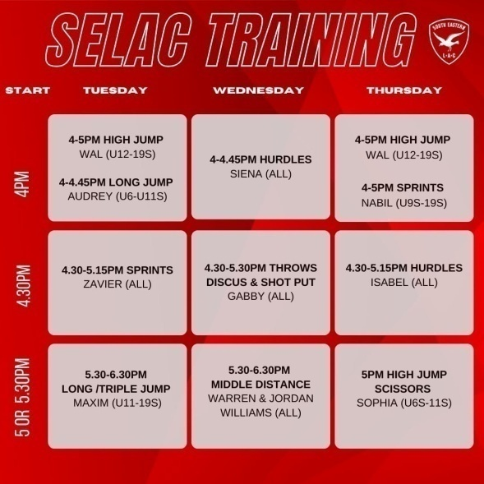
The SELAC training sessions continue this week. Please remember to register and pay as well will check names from this week forward. If you are found at training without previously paying you will need to pay a $20 fee per athlete.
With 11 training sessions available for athletes there is something for everyone!!
Please see the training schedule attached and sign up using the link:
https://forms.gle/EGXHQrcDvsG1zG6e7

If you want to attend SELAC sponsored training you need to sign up and pay before you start.

SELAC Senior Athletics Club - Athletes are now able to register to compete in ANSW senior events while representing South Eastern Little Athletics. Please see the link. https://www.revolutionise.com.au/selac/registration/

PB-Athon -The PB-Athon wrapped up this week. Keep racking up those PB’s.

General Information;

State Relay – Athletics is on as normal while the State Relays are on so your Age Marshal may not be there. Please assist where you can.

Track & Field Status – Were back on the original program two this week.

On the Day
Set-up is from 7.15am. Please make sure that as many parents as possible lend a hand to set-up.
Due to the 3k there will be no walks this week.

Club Championships - There is just one event to complete (3K). This will be run at 7.45am with Sean.
BBQ - The U13 and Seniors parents are on BBQ/Canteen duty, please assist in the Canteen.

We will also be running Graded 1500 this week and Graded 400s. Anyone that has not got a time and wishes to run will need to see Sean at 8.30am.
Other track events start at 8am with the P300 (U6s), P500 (U7), P700 (U8), 800m (U9 & U10) Graded 1500 (U11s upwards). The long hurdles will run in parallel with these. We will then have the 50m and 100m sprints followed by the graded 400m.

See you on Saturday.

SELAC Committee

